**Interacting Professionally with the Instructor.**

I have communicated with Brother Lawrence as freely and professionally as I was able to. My messages were done primarily through the online portal for Canvas. Including reaching out when my group seemed to have whittled down to just me, as I was unable to reach anyone else in my group for a month.

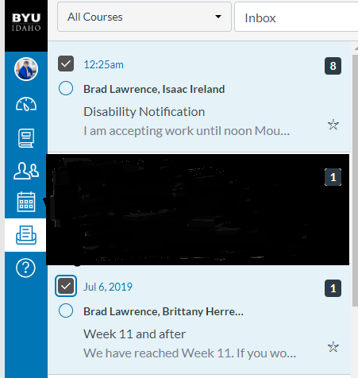

**Interacting Helpfully and Professionally with Other Teams.**

Using the forum boards provided by Canvas, I would read the posts and make sure I expressed my self clearly and tried as often as I could to give direct feedback on the topics on hand.

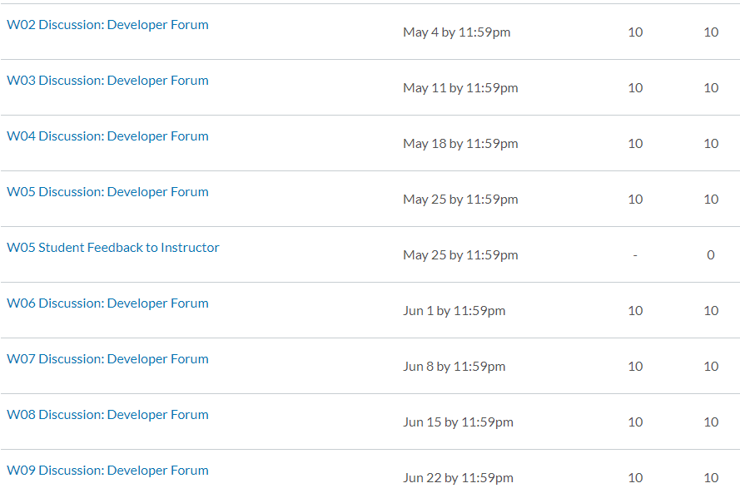

**Supporting the Team by Teaching, etc.**

We would meet as a team each week, while we were in contact. I would meet and teach using zoom as often as I could, and if I could not, I would do a recording about the topic I was to cover and send it to them with in 2 days, so that they could ask questions and give feedback when they were able. When Felix expressed concern, I was there to talk with him, and I offered to join him on Zoom to answer any questions he may have had on any subject that I knew.

**Self-Reflection/Meta-Cognition.**

I understand that I can do a lot, while I may struggle on some programing topics, I have learned that there is nothing I can’t do with some help and trial and error. I also learned how to better handle debugging and roadblocks. I have found that having several programs to build my java apps (namely eclipse, netbeans and VS studio) can help me get something to work, once I get something to work I have a better understanding of why I was struggling in my other methods, and that can help a lot in the long-run. I have found in the past debugging dis-heartening, but I have a lot more confidence now than I did before.

**Team's Agile Methodology.**

We agreed to do scrum, with Kanban boards.